**Our Project is Hospital management the url is**: <https://github.com/nirravv/Hospital-Management-Html>

My GitHub repository where I did updations link is:https://github.com/navjotpreet/SCRUMAssignmentTWO

**Why we chose this Project**: Because hospital management is one of the biggest terms that every user in their daily life. I am a programmer and tester so I can give enough changes as per the requirements and I can fix the bugs which we found on the website. They will update later for additional work also. After I can perform manual testing as well. There are some design issues, and our team designer will work on them.

**Programming Part:**

I made the forms dynamic so that they can be usable by end users.

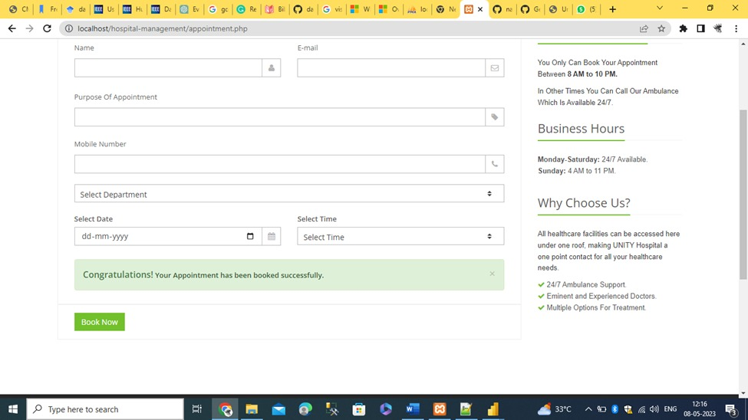

**Testing Part:**

I will go for the manual testing to enhance the functionality of the software.

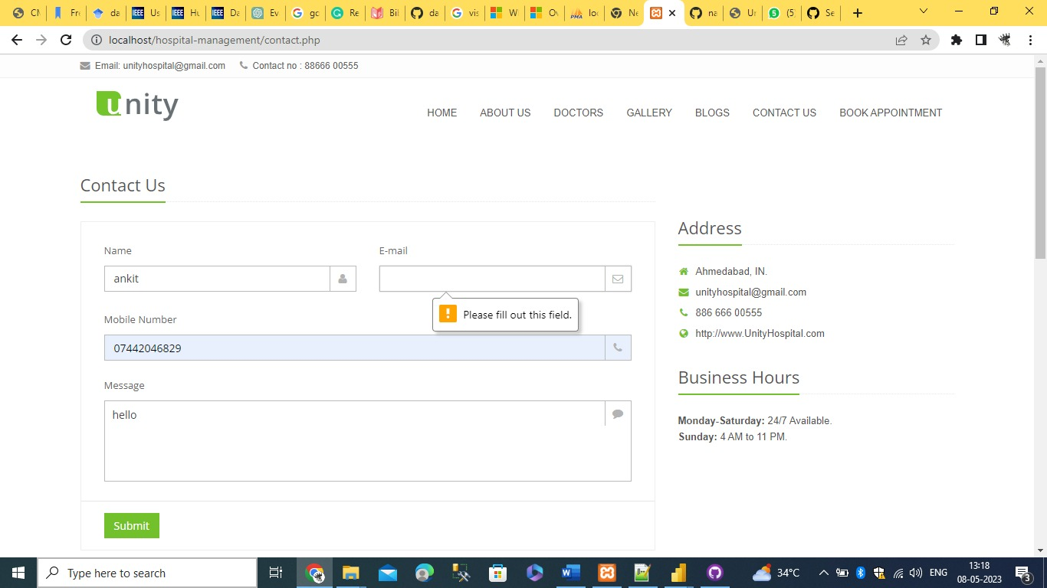

**Updates on these area as well:**

Tell me about your backend language you use to make it dynamic and explain about your database language also in brief

Every software application that is developed must take the backend into consideration. In this project PHP and Javascript programming languages used for backend .And mysqli used for database.